# COSC2196 Introduction to Information Technology

## Assessment 1: My Profile

### Name: Rob Mitchell

### Student Number: S3831027

### Email: [nineraphael@gmail.com](mailto:nineraphael@gmail.com)

## My IT Profile

**Basic Background**: I am 42 years old and have been working for the WA State Government for approximately 14 years. My first role in WA State Government was as a Transit Guard providing security and passenger services on trains. On one shift, I assisted my supervisor with connecting a printer and my passion for IT started immediately. I had previously setup computers and basic IT at home but the reward I received in that single moment started my current career. I went from earning over $100,000 a year in a security role to starting in a service desk position earning less than half the money but getting the daily reward of solving problems.

Since starting as a service desk officer, I have managed a service desk; lead the upgrade projects of multimillion-dollar system upgrades and completed the whole of Government Key Performance Indicator reporting for the 2018 reporting cycle. I have enjoyed my career however never completed formal IT training, other than online Microsoft sessions or attended group scenarios. I looked within the TAFE environment however; I could not find any qualifications without attending classes for a year. I found this course within RMIT and signed up immediately. Once completing this course, I will look at continuing my education.

**Ideal job:** Ultimately, I would love to become a Chief Information Officer within WA State Government bringing a team of staff to achieve amazing things. I have been privileged with some great leaders that I believe I have learnt leadership capabilities however at that level within ICT, more and more Agencies are seeking qualifications that I currently do not possess.

Office of the Auditor General – Chief Information Officer - <https://search.jobs.wa.gov.au/page.php?pageID=466&windowUID=0&AdvertID=245804>

This particular position is a leadership role that strives for greater efficiencies and effectiveness that I believe I have demonstrated in my current role and the opportunity I had to transfer to the Officer of the Government Chief Information Officer – Associate Director Strategic Business Transformation. The concern I have with applying for these types of roles is my ability to address the selection criteria and be competitive against other applicants. I have had opportunities in technical and non-technical roles however detailing these skills against a selection criteria is my downfall. By completing this course along with developing a better application, I hope to gain the type of roles that will ultimately get the Chief Information Officer role.

**Personal Profile:**

Crystal knows profile: <https://www.crystalknows.com/p/robmitchells3831027>

Myer Briggs: 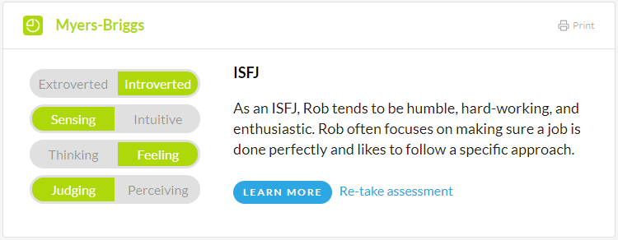

Open Source Psychometrics Project: <https://openpsychometrics.org/tests/IPIP-BFFM/results.php?r=3.3,3.1,3.9,3.3,3.2>

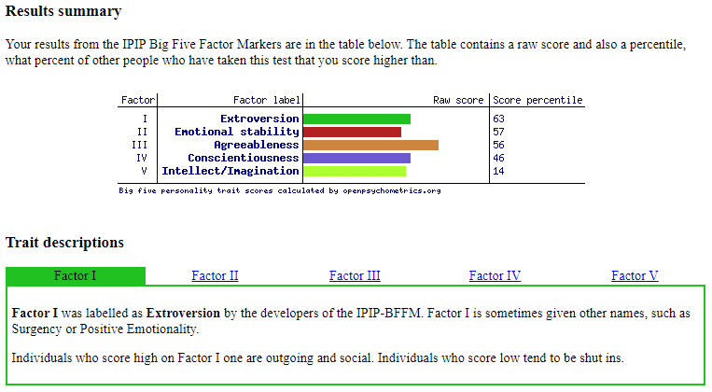

Summary: I believe these results reflect how I act at work. I lead a team of four staff currently and my focus is that my staff feel valued and are happy. I have often not tasked someone with a task if they are not in the right headspace and completed it myself.

**Project: Implementing Chatterbot to Department of Training and Workforce Development**

**Overview:** In 2011 the Department of Training and Workforce Development (DTWD) was created as part of a Machinery of Government (MOG) decision. Part of this decision was to separate the Department of Education and Training to become the Department of Education and DTWD. I commenced working at DTWD as a direct Government transfer from WA Police with the support of my Associate Director. My initial role was to develop all the IT service management processes based on the ITIL framework. The final piece of this implementation of new processes, I was tasked with implementing a toolset to support the newly developed processes without losing historical data and requests.

**Motivation:** My current role is the Business Relationship Manager with the responsibility of staff that provide now manager ITIL process, IT Governance and Project Management. Monthly, my staff report on the number of service request and incidents that have been lodged with the Service Desk but also responsible for all Changes to the IT environments.

On several occasions, there are specific services that have limited information or facts about how to request, utilise or purchase a service. For example, the Department has recently upgrade to Office365 and some of our customers understand how to use Microsoft Teams but do not know how to request a site or understand how it can be expanded to other areas.

**Description:** Recently a number of team members have attended sessions with Microsoft training sessions and have mentioned the new features of creating chatterbots through Azure and how amazing the experience to our customers could be. A customer can access our existing self-service portal but with some development, be greeted by a chatterbot that has previously crawled out FAQs and user guides, as an example, and provide information that potential could provide faster resolution times and information that is more accurate. Since the original MOG decision, staff numbers both within the entire Department and within our ICT branch have reduced however with the advancements of technology and systems, the demand for support has grown. Previously, the service desk for example was a ratio of 1 support staff to 1 customers. This ration is now 1 to 200. With increasing request for service of our customers that are not as comfortable with developments in technology, it is a requirement to look at better options to be able to support these staff.

My personal experience recently attempting sell my car, really cemented the idea and potential benefit of this type of service could provide to ICT customers. A customer calls the ICT service desk and currently has to wait for their phone call to be answered by an analyst. Depending on the staff member that answer the phone call, they could be greeted with a newly appointed staff member or a seasoned professional that has a wealth of knowledge. The same result could occur with an email the customer sends to the service desk with a response again from a variety of staff members. The Department has implemented a basic self-service catalogue however it requires the customer to have a good understanding of that they are requesting. This may sound simple however a recent request has come to the service desk requesting the Department stop using Office365 because they didn’t know their files were being stored in OneDrive and couldn’t find their document within the documents folder on their PC. However, what if while the customer was trying to use the self-service portal a friendly “bot” appeared, asked some questions and was able to provide answer that met their requirements? What would also happen if the inexperience staff member were able to access a different “bot” that they could access to be able to assist with the customer question more accurately and efficiently?

My project will be implementing two “bots” that will be able to be accessed by our customers and by our IT department for technical assistance. A series of information will gradually be developed and expanded and more knowledge is obtained which will increase the services provided to the IT customers. The current staff pain points will be the first to be added and then constant iterations to grow the knowledge base. Access to the “bots” will be based on their log in credentials or active directory accounts that will ensure the staff member (customer or IT Support) will automatically reference the correct “bot” to also reduce confusing and potentially over complicated responses for non IT staff.

**Tools and Technologies:** DTWD is currently considered a Microsoft shop utilising Azure, Active Directory, Office 365, Microsoft System Centre (Operations, Service Manager and Configuration Manager). Part of my project will be reviewing potential tools and technologies and looking at the best options to suit the current Microsoft products. Ideally I would prefer to not have to change existing tools however if the end product is able to significantly provide better support to our customers and reduce time for support staff, replacing existing tools could be considered.

I will be commencing my research on the ever-changing Microsoft Power Apps framework looking for a simple solution that will enhance the current tools. A large number of FAQs, user guides and work instructions exist, presenting this information based on a search topic or key word is the starting point.

**Skills Required:** To commence this project I will be required to understand a number of key items. I need to review where the current documents or information is stored and then confirm if the is the information still correct. Research available Power Apps and other tools that may be able to fulfil my project. I may consult with vendors or other experts to confirm that the potential tools will meet my requirements.

Once a tool is selected, the technical integration could require anything from xml imports to customized APIs pushing data between services. Until the final tool is selected, I can only predict the skills required.

**Outcome:** To understand the ultimate outcome of this project will require even more research. Currently, the ICT service desk receive approximately 20 emails and 20 phone calls per day. A number of service requests currently require email approval for specific items so I am not expecting this number of request to reduce significantly, however the expectation is there should be a noticeable difference in phone calls.

The current service management toolset records the method that the customer contacts the service desk whether phone, email, online or in person. With this in mind, I will be conducting statistics for the last 12 months to really understand the peaks and troughs through busy periods during a year. With this information, my focus will also be identifying the common or consistent services that are required and will be the prioritized for implementation based on these figures.

**References:**

Ideal job found on WA Government Job Site – [www.jobs.wa.gov.au](http://www.jobs.wa.gov.au)

Personal profile created on Crystalknows.com including link to Myer-Briggs assessment - <https://www.crystalknows.com/p/robmitchells3831027>

Big Five Personality Test assessment completed on Open-Source Psychometrics Project - <https://openpsychometrics.org/tests/IPIP-BFFM/results.php?r=3.3,3.1,3.9,3.3,3.2>